# CHAPTER 1

# INTRODUCTION

## 1.1 Introduction

In this world of chaos and stress, what we sometimes need is a tranquil and spiritual rest. A Spiritual journey, which will lead to personal enlightenment and emotional well-being, offers a great way to achieve peace. To find deeper meaning and connections, many people are using “Spiritual Travel” as a path for their personal growth and fulfilment. The Tranquil Trails is a Large Language Model which serves as a guide for Spiritual travel, explaining in detail about the best spiritual spots, mindful meals, and wellness activities. This model is designed to assist travellers in exploring places that resonate with their spiritual and personal growth goals. By using Natural Language processing, it provides meaningful advice and content. Whether one is embarking on a pilgrimage, visiting sacred sites, or engaging in wellness retreats, this model aims to enrich the journey by fostering a deeper understanding and connection to the places visited.

## 1.2 Objective

The Tranquil Trails project is an attempt to transform the model of finding and consuming serenity and health via the trail. With the help of the capabilities of the modern LLMs, the project aims to provide users with personalised, conversational services where they will be shown the best spiritual places, places to get a healthy meal, or recommended wellness activities according to their preferences. Furthermore, the project outline involves various aspects:

### *Personalized Wellness Travel Guidance*

It will provide interactive and personalised recommendations for users seeking tranquil and wellness-focused trips. The model will offer tailored suggestions for spiritual spots, mindful meals, and wellness activities based on individual preferences.

### *Regional Spiritual Practices Information*

Incorporate detailed information about spiritually enriching practices unique to various regions. This will enable users to gain deeper insights into local cultural and spiritual traditions, enhancing their travel experiences and fostering a greater appreciation for different customs.

### *Enhanced Text Generation with Custom Datasets*

Explore the capabilities and implications of text generation using pre-trained language models, with a specific emphasis on utilising custom datasets. This will help improve the model's ability to produce human-like text, thereby opening new possibilities for various applications in travel, wellness, and spirituality.

### *Transport and Accomodation*

The project offers detailed transportation options for each region. This includes major airports, railway stations and road connectivity. This ensures seamless travel planning. It provides recommendations on local cuisine. Popular and traditional dishes are highlighted. This allows travellers to experience the regional flavours fully. Additionally, the project suggests various accommodation options. These range from luxurious heritage hotels to cosy guest houses. This ensures a comfortable and memorable stay for all travellers.

## 1.3 Scope

The scope of this project extends to enhancing both daily life and various industry sectors by providing comprehensive wellness travel guidance and regional spiritual practices information. In daily life users can leverage the platform for personalised travel planning. They will discover tailored recommendations for meditation practices, spiritual landmarks and local healing methods. Thus, the platform will enrich their travel experiences. It supports mental and spiritual well-being by offering detailed insights into diverse meditation techniques. Traditional healing practices are included. Users can integrate these into their daily routines. Additionally, the platform fosters cultural awareness and learning. It enables users to explore the cultural and historical significance of various regions and their spiritual traditions. Volunteer opportunities highlighted by the platform encourage community engagement. Social contribution is promoted. Moreover, the inclusion of local health and wellness practices offers users natural remedies and therapies for improved well-being.

In the industry sector the project provides significant benefits to travel and tourism. It aids travel agencies and tour operators in designing personalised travel packages focused on wellness and spirituality. This promotes lesser-known spiritual landmarks and boosts regional tourism. Wellness centres and retreat organisers can use detailed information to create programs that cater to diverse needs. They offer unique retreat experiences. Educational institutions can employ the platform as a resource for teaching cultural diversity, spirituality and regional heritage. Healthcare providers can integrate traditional healing practices into holistic treatment plans. The hospitality industry can enhance guest experiences by providing customised wellness activities. They provide information on nearby spiritual landmarks. Content creators and media outlets can utilise rich data for producing engaging content. They focus on regional spiritual practices and wellness tourism. They attract broader audiences. Overall, this project has potential to enhance personal well-being, promote cultural understanding and provide valuable tools and insights across various industries.

## 1.4 Report Structure

This report has been organised into various chapters as follows:

### **Chapter 1:**

This chapter introduces the concept of the project, its objectives, and the scope. It sets the context for the entire report and provides a roadmap for the following chapters. It begins with an overview of the problem or opportunity that the project addresses, explaining why it is important. The objectives of the project are clearly defined, outlining what the project aims to achieve. The scope of the project is discussed, specifying the boundaries and limitations.

### **Chapter 2:**

This chapter reviews existing literature and research relevant to the project. It provides a theoretical foundation and highlights previous work that informs and supports the project's development. The literature review includes a survey of key concepts, theories, and methodologies related to the project. It discusses the strengths and weaknesses of existing studies, identifies gaps in the current knowledge, and explains how the project aims to address these gaps. By situating the project within the context of existing research, this chapter justifies the need for the study and its potential contribution to the field.

### **Chapter 3:**

This chapter explains the methodology used in the project, including data collection, preprocessing, and the tools and techniques employed. It outlines the systematic approach taken to achieve the project goals. The methodology section describes the design of the study, the data sources, and the criteria for data selection. It details the processes and steps followed to collect and prepare the data, including any preprocessing techniques used to clean or transform the data. The chapter also covers the tools, technologies, and software used in the project, and explains the analytical methods and models applied to derive results.

### **Chapter 4:**

This chapter presents the results obtained from the project, followed by a detailed discussion. It analyses the outcomes, evaluates the performance, and discusses the implications of the findings. The results section provides a clear and concise presentation of the data and outcomes generated by the project. This may include tables, graphs, and other visual aids to help interpret the results. The discussion section examines the significance of the results, comparing them with expectations and findings from the literature review. It also explores the limitations of the study, potential sources of error, and the reliability of the findings.

### **Chapter 5:**

This chapter brings the report to a close by summarising the key points and findings from the project. It reiterates the main objectives and how they were met through the project work. The conclusion section synthesises the insights gained and reflects on the overall contribution of the project to the field. Following the conclusion, the chapter outlines potential future advancements, suggesting ways to build upon the project's success. It highlights areas for further research, improvements to the methodology, and potential applications of the findings. This forward-looking section provides a roadmap for future work and underscores the project's ongoing relevance and potential impact.

# CHAPTER 2

# LITERATURE REVIEW

## 2.1 Natural Language Processing

Natural Language Processing (NLP) is a branch of artificial intelligence that bridges the gap between computers and human language. It allows computers to comprehend, Interpret and manipulate our language. NLP encompasses such activities as translating languages, recognizing emotions in text and translating speech. Large Language Models (LLMs) are useful in NLP. They were trained on huge amounts of textual data. This allowed them to be very creative with text generation even when it comes to the most complicated and unusual queries. Moreover, they can answer your questions in an informative way. [1]

Large Language Models or LLMs are an evolved version of NLPs. They use advanced deep learning techniques to attain significant levels of language comprehension and generation. This eventually led to text generation systems that closely mimic human expression and understanding.

## 2.2 Large Language Models

Today the LLMs are based on Transformer language models that contain a large number of parameters. They are trained on massive text data. They contain multi-head attention layers. These are stacked in deep neural networks which are a crucial part of the LLM structure. It captures the relationship between different words. It encodes the context and comprehends and produces textual output. Initially, these models undergo pre-training. They learn general language abilities. Subsequently they can be fine-tuned on specific tasks. To enhance their performance, they include question answering text summarization or sentiment analysis. [2]

The effectiveness of this approach is seen in models like OpenAI's GPT series and Google's BERT. [3]This results in achieving state-of-the-art performance across various NLP tasks. GPT models in particular, have gathered attention, they are notable with their ability to generate coherent and contextually relevant text is significant. This applies across diverse prompts and domains.

## 2.3 LangChain

LangChain is a robust framework designed to streamline development of applications. It integrates large language models (LLMs) into complex workflows. Its modular architecture allows developers to seamlessly connect various components. These include text generation. Data retrieval and interaction with external APIs is also supported. This enables creation of sophisticated natural language processing (NLP) applications. It abstracts the complexities involved in managing and orchestrating multiple LLMs. LangChain allows developers to focus on innovation. They are not bogged down by the underlying intricacies. One of its standout features is ability to manage state across multiple interactions. This makes it ideal. For building context-aware conversational agents. Chatbots benefit greatly from this capability[4].

LangChain supports integration with a wide range of data sources. These include databases. Knowledge graphs are also supported. External APIs can be integrated. This integration enhances models' ability. Performance has improved. Accurate and detailed information is provided.

The framework emphasises scalability. It focuses on performance as well. It caters to both batch needs. Real-time processing is supported too. This makes it adaptable for various use cases. Examples range from customer support chatbots. Complex decision-making systems in finance benefit as well. Healthcare applications also benefit from it. LangChain includes built-in tools for monitoring. It optimises model performance. This ensures that applications remain responsive. Reliability is maintained. [5]

Overall LangChain is a comprehensive platform. It simplifies the development of advanced NLP applications. It provides flexible, scalable and performance-oriented solutions.

## 2.4 GoogleGenerativeAIEmbeddings

Google Generative AI Embeddings is a layered process developed by Google that uses state-of-the-art generative AI models to create rich, high-dimensional data representations. Embeddings capture the underlying meaning of a word, sentence, or even larger text, enabling more accurate and context-aware natural language recognition (NLP) tasks. By transforming data into dense vectors, Google Generative AI Embeddings support a variety of applications including text classification, sentiment analysis, information retrieval, and recommendations. What makes them particularly useful for complex NLP tasks is their ability to create the perfect product that captures the nuances of the content. These embeddings are pre-trained on big data, allowing them to capture many languages ​​and relationships. [6]

It is also designed to be used easily in existing projects, to give developers the opportunity to improve the functionality of their projects. With its ease of integration, power, and versatility, Google Generative AI Embeds is a valuable resource for businesses and researchers looking to implement AI technology in their business.

## 2.5 RetrivalQA

RetrievalQA is a component in LangChain designs for retrieval-based question answering tasks. It joins language models with retrieval mechanisms to find relevant documents or passages based on a user query. This enhances the accuracy and relevance of answers by leveraging retrieved information. RetrievalQA is particularly useful for applications requiring contextual understanding and factual accuracy, making it a powerful tool in NLP for generating informative responses based on available text sources.

The module employs advanced indexing techniques and algorithms, optimising search speed and scalability for handling large datasets effectively. By leveraging these methods, RetrievalQA can swiftly retrieve pertinent information, making it suitable for real-time applications where quick and accurate responses are crucial.

Applications of RetrievalQA span diverse domains including information retrieval, customer support automation, educational tools, and more. It excels in scenarios requiring precise answers backed by evidence from existing text sources, thereby supporting tasks ranging from fact-checking to in-depth query responses.

## 2.6 FAISS

FAISS, which stands for Facebook AI Similarity Search, is a high-performance library for efficient similarity search and clustering of dense vectors. It is widely used in machine learning. It is also used in information retrieval applications. The goal is to find items that are similar to a query item based on vector embeddings.[7]

At its core FAISS leverages the concept of indexing to accelerate the search process. It supports different indexing methods optimised for various use cases, including:

### *Flat Index:*

This is the simplest form of indexing where all vectors are stored in a single flat list. While straightforward it can be impractical for large-scale datasets due to memory constraints.

### *IVF (Inverted File System):*

IVF-based methods divide vectors into clusters using a quantization technique. Each cluster is indexed separately. This improves search efficiency by reducing the number of comparisons needed during retrieval.

### *PCA (Product Quantization with Cartesian K-means):*

This method decomposes vectors into smaller sub vectors using vector quantization techniques. It offers a good balance between search speed and memory usage.

* *HNSW (Hierarchical Navigable Small World):*

HNSW creates hierarchical graph structure where vectors are connected based on their similarity. It enables fast approximate nearest neighbour search in high-dimensional spaces.

FAISS is optimised for modern hardware architectures. It supports both CPU and GPU computations. This makes it versatile for different deployment environments.

Applications of FAISS include image and video acquisition. It is used for natural language processing such as semantic search. Similar information is another application. It is used in approval systems. It helps with large groups of documents. Efficient indexing and support for large-scale searches make FAISS useful. Optimises search and retrieval tasks in various machine learning applications

## 2.7 Prompt-template

In LangChain, a prompt template is a crucial component designed to streamline the creation and management of prompts used for interacting with language models. A prompt template in LangChain is essentially a structured way to define the text input given to a language model, incorporating variables and dynamic content to tailor the prompts to specific tasks and contexts. This template system allows developers to specify placeholders within a prompt that can be filled with actual data or parameters at runtime, ensuring flexibility and reusability. In our project prompt template includes placeholders like {context} and {question} which will be filled with actual context and question text during runtime.

Prompt templates in LangChain can include various elements such as fixed text, variables, and control structures. For instance, a template might contain a mix of static instructions and dynamic placeholders that are replaced with user inputs or data from other sources. This approach simplifies the process of prompt generation. This is especially true for complex applications. These require prompt content to adapt based on different scenarios or user interactions.

Using prompt templates developers can maintain consistency in how prompts are structured. Reduce the risk of errors. Enhance scalability of applications. These templates can be stored, managed and versioned within LangChain. Thus making it easier to update and refine prompts as the application evolves. Overall, prompt templates in LangChain provide a powerful mechanism for creating effective and dynamic interactions with language models, enabling developers to leverage the full potential of natural language processing in their projects.

## 2.8 StreamLit

Streamlit is an open-source app framework that revolutionises how developers create and share custom web applications for machine learning and data science projects. With its simple and intuitive API Stream It allows users to build powerful and interactive data apps using only Python. This eliminates the need for complex front-end development skills. Streamlit offers a wide array of interactive widgets like sliders, buttons and file uploaders. This enables developers to create engaging user interfaces effortlessly. It supports real-time data updates. This makes it ideal for dynamic applications involving live data streams or real-time analytics. Seamless integration with popular data visualisation libraries like Matplotlib Plotly and Altair allows for rich interactive visualisations.[8]

Streamlit simplifies deployment and sharing through services like Streamlit Sharing Heroku and AWS. This facilitates broad accessibility. It also promotes collaboration. Its open architecture enables extensive customization and integration with various APIs and external services. Supported by an active community and comprehensive resources, Streamlit is an invaluable tool for quickly transforming data scripts into interactive shareable web applications. This makes it essential for machine learning data science and data-driven projects.

# CHAPTER 3

# METHODOLOGY

# 

## 3.1 Weekly Flow ChartWeek 1

Fig 3.1.1. : Weekly Flowchart: Week-1

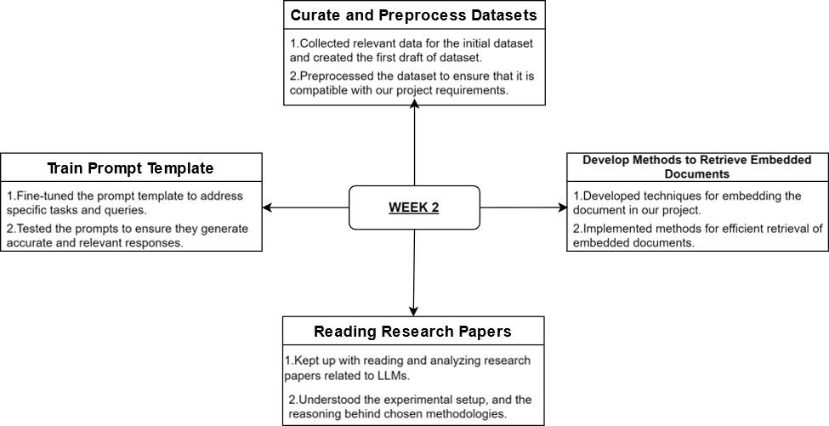

Fig 3.1.2. : Weekly Flowchart: Week-2

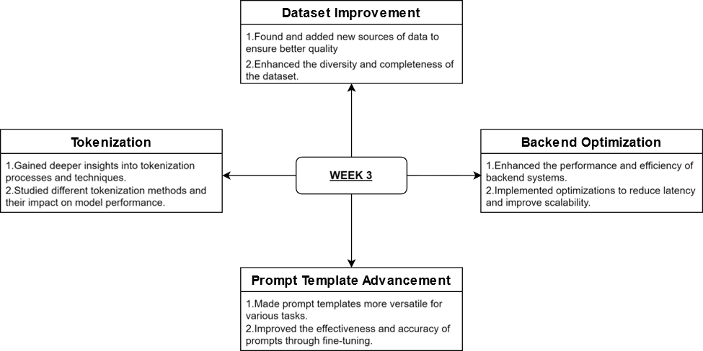

Fig 3.1.3. : Weekly Flowchart: Week-3

# 

Fig 3.1.4. : Weekly Flowchart: Week-4

# 

# 

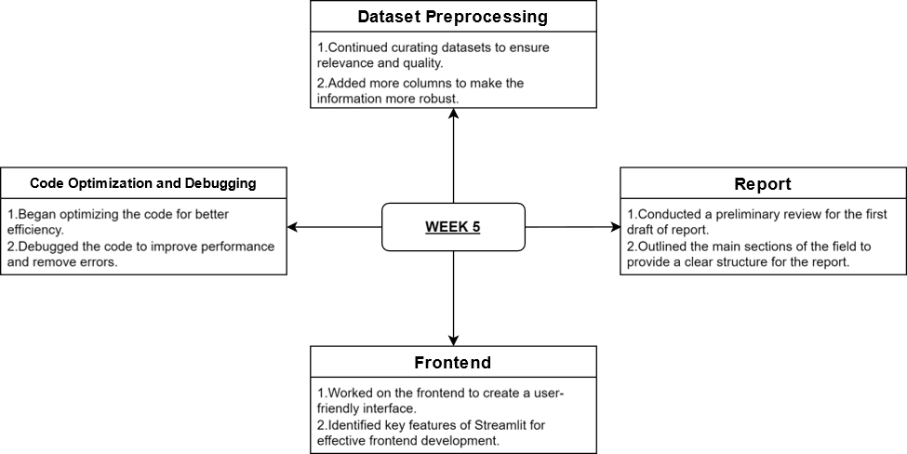

Fig 3.1.5. : Weekly Flowchart: Week-5

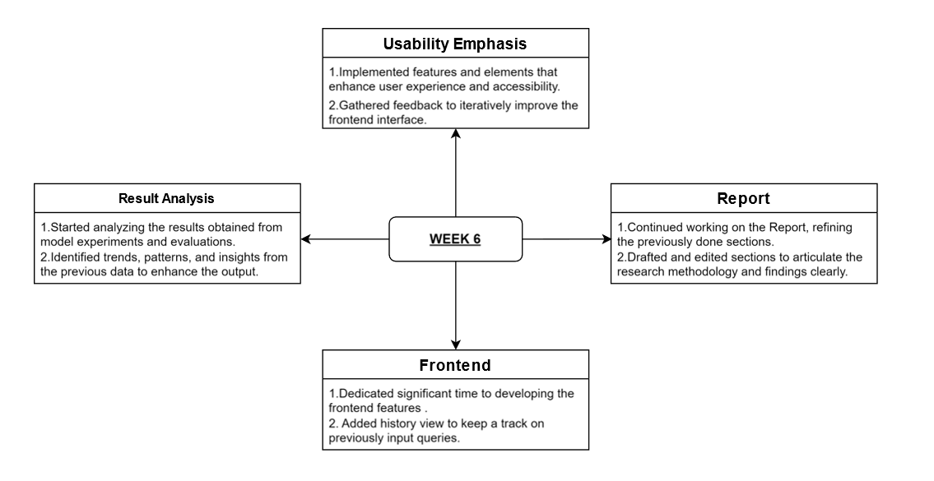

Fig 3.1.6. : Weekly Flowchart: Week-6

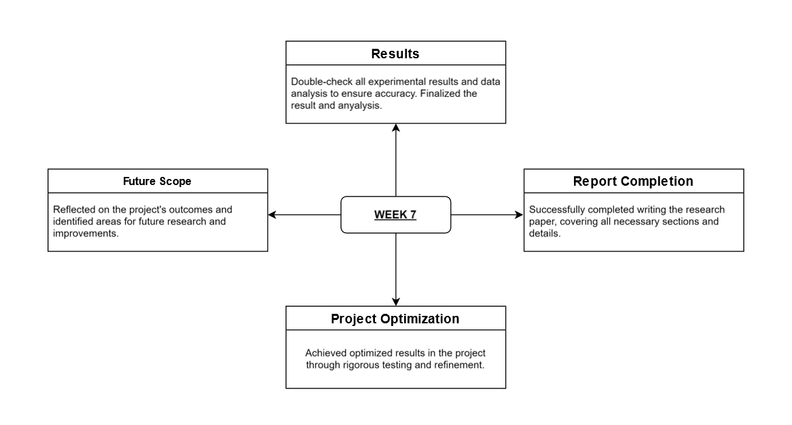

Fig 3.1.7. : Weekly Flowchart: Week-7

## 3.2 Dataset

The dataset we used in this project is custom-made. It provides a detailed overview of the meditation practices, traditional healing methods and spiritual landmarks in various states and union territories of India. Each entry includes the state or union territory's name. It also contains the capital, categorised by region (North South, East West). The dataset highlights the type of meditation practised, like Vedantic Meditation, Buddhist Meditation Sankirtan and Vipassana, along with their philosophical or religious origins like Hindu philosophy Buddhism, Vaishnavism and Christianity. The dataset describes local healing practices which include Ayurvedic treatments. It also covers herbal baths, traditional massages and yoga. For each state or union territory, significant spiritual landmarks are listed. These landmarks come with their historical or religious importance. Information on the availability of local guides and the best time to visit is provided. This assists travellers in planning their trips. Transportation options including airports and railway stations, are mentioned. Recommended accommodation options like heritage hotels and guest houses are included.

Additionally the dataset highlights volunteer opportunities. These include temple volunteering, monastery assistance and community health projects. Finally it features a list of local foods and dishes. Travellers can enjoy these during their visit. This offers a comprehensive guide to the spiritual and cultural richness of each region.

The dataset consists of several columns that provide comprehensive information on meditation practices, traditional healing methods, spiritual landmarks and travel-related aspects of various states and union territories in India. Here is detailed description of each column:

### **States + UTs**:

This column lists the names of the states and union territories in India. It helps in identifying the geographical area covered in each entry.

### **Capitals:**

This column specifies the capital city of each state or union territory. It indicates the administrative centre of the region.

### **Region:**

This column categorises each state or union territory into one of India's geographical regions. These regions are North, South, East and West. This classification aids in understanding regional practices and traditions.

### **Meditation Type:**

This column describes the predominant type of meditation practised in each state or union territory. Examples include Vedantic Meditation Buddhist Meditation, Sankirtan Vipassana Meditation etc.

### **Origin:**

This column provides the philosophical or religious origin of meditation practice. Such as Hindu philosophy, Buddhism, Vaishnavism and Christianity. It gives context to meditation practices listed.

### **Focus:**

This column outlines the main focus or goal of meditation practice such as understanding non-dual reality. Mindfulness and compassion, devotion through music insight and awareness of reality are other examples.

### **Method:**

This column describes methods used in meditation practice. It includes activities like reflection and mental discipline, focusing on breath and visualisation techniques. Group singing and dancing are mentioned. Observing bodily sensations etc.

### **Local Healing Practices:**

This column details traditional healing practices used in each region. It includes Ayurvedic treatments, herbal baths.

### **Spiritual Landmarks:**

This column lists key spiritual landmarks in each state or union territory. Examples include temples, monasteries, churches and other significant religious sites.

### **Significance of Landmark:**

This column explains the historical or religious importance of the spiritual landmarks listed. It indicates their relevance to the local culture and spirituality.

### **Local Guides:**

This column provides information on the availability of local guides for tourists. It helps travellers find guided tours. It also provides local expertise.

### **Best Time to Visit:**

This column suggests the best time of the year to visit each state or union territory considering the local climate. It also considers cultural events.

### **Suggestive Itinerary (no of days):**

This column suggests the duration of stay for a meaningful visit, ranging from 5 to 10 days. This depends on the region. It also considers activities available.

### **Transport:**

This column lists the transportation options available including nearest airports, railway stations and major road connections.

### **Accommodation Option:**

This column provides suggested accommodation options. These include hotels guest houses and heritage properties

### **Volunteer Opportunities:**

This column shows the volunteer opportunities available in the region including temple and monastery volunteering.

### **Food:**

This column lists local delicacies that travellers can try. It showcases the culinary diversity of each state or union territory.

## 

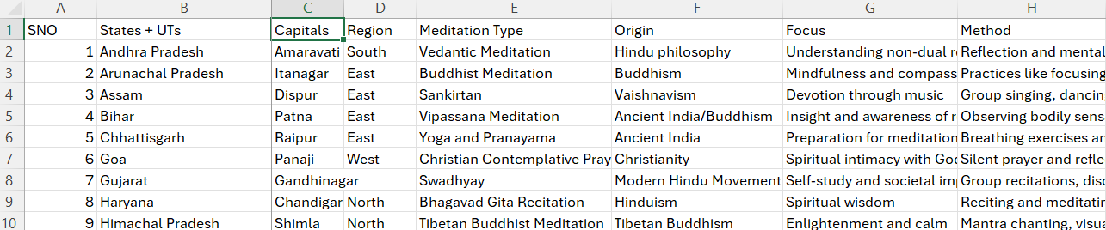

Fig 3.2.1. : Dataset(1)

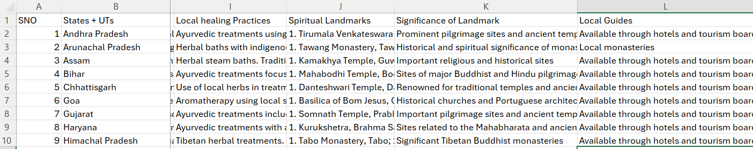 Fig 3.2.2. : Dataset(2)

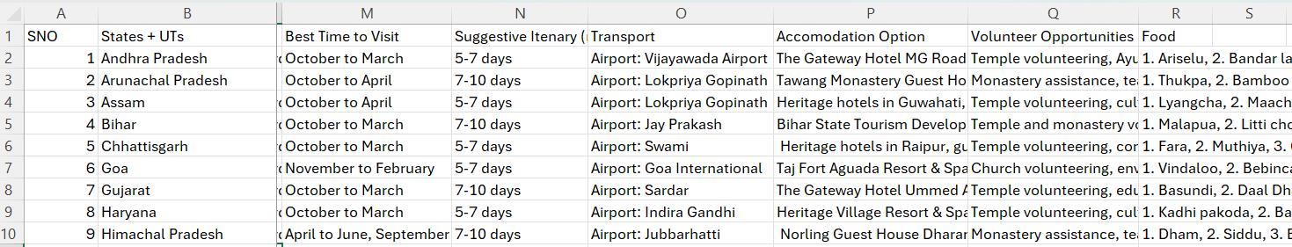

Fig 3.2.3. : Dataset(3)

## 3.3 Code

### #Helper

import streamlit as st

import os

from langchain_google_genai import GoogleGenerativeAIEmbeddings

import google.generativeai as genai

from langchain_community.vectorstores import FAISS

from langchain_google_genai import ChatGoogleGenerativeAI

from langchain.chains import RetrievalQA

from langchain.prompts import PromptTemplate

import os

from hello import api_key

os.environ['GOOGLE_API_KEY']=api_key

from langchain_google_genai import GoogleGenerativeAI

llm=GoogleGenerativeAI(google_api_key=api_key,model='models/text-bison-001', temperature=0.9)

# llm=google_palm(google_api_key=api_key,temperature=0.6)

from langchain.document_loaders.csv_loader import CSVLoader

embeddings = GoogleGenerativeAIEmbeddings(model="models/embedding-001")

e = embeddings.embed_query("Goa")

len(e)

instructor_embeddings = GoogleGenerativeAIEmbeddings(

model="models/embedding-001", task_type="retrieval_query"

)

vectordb_file_path = "faiss_index"

def create_vector_db():

loader = CSVLoader(file_path="project.csv", source_column="States + UTs")

data = loader.load()

vectordb = FAISS.from_documents(documents=data,embedding=instructor_embeddings)

vectordb.save_local(vectordb_file_path)

# retriever = vectordb.as_retriever(score_threshold = 0.7)

# rdocs = retriever.get_relevant_documents("" meditation")

# rdocs

def get_qa_chain():

vectordb = FAISS.load_local(vectordb_file_path, instructor_embeddings, allow_dangerous_deserialization=True)

retriever = vectordb.as_retriever(score_threshold = 0.7)

prompt_template = """Given the following context and a question, generate an answer based on this context only.

In the answer try to provide as much text as possible from "response" section in the source document context without making much changes.

If the answer is not found in the context, kindly state "I don't know." Don't try to make up an answer.

CONTEXT: {context}

QUESTION: {question}

Please provide a detailed and comprehensive answer that includes multiple aspects and detailed explanations where possible.

"""

PROMPT = PromptTemplate(

template=prompt_template, input_variables=["context", "question"])

chain_type_kwargs = {"prompt": PROMPT}

chain = RetrievalQA.from_chain_type(llm=llm,chain_type="stuff",retriever=retriever, input_key="query",return_source_documents=True, chain_type_kwargs=chain_type_kwargs)

return chain

if __name__ == "__main__":

create_vector_db()

chain = get_qa_chain()

### #Main

import streamlit as st

from helper3 import get_qa_chain, create_vector_db

# Set up the page configuration with an aesthetic that follows an Indian-inspired theme

st.set_page_config(

page_title="TRANQUIL TRAILS Q&A",

page_icon="🌱",

layout="wide",

initial_sidebar_state="collapsed"

)

# Define theme colors

background_color = "#F2EFEA" # Light beige

accent_color = "#FF6B6B" # Coral red

text_color = "#1A1A1D" # Charcoal black

button_color = "#FF6B6B" # Coral red

button_color_grey = "#A9A9A9" # Grey

description_color = "#4B4B4B" # Darker grey for visibility

# Apply custom styles to the page for aesthetics

st.markdown(

"""

<link href="https://fonts.googleapis.com/css2?family=Playfair+New+Zealand&display=swap" rel="stylesheet">

<style>

.reportview-container {

background-color: #F2EFEA;

color: #1A1A1D;

}

.stTextInput>div>div>input {

background-color: #F2EFEA;

color: #1A1A1D;

font-family: 'Poppins', sans-serif;

font-size: 18px;

margin-bottom: 0px !important; /* Remove bottom margin */

text-align: left; /* Align text input to the left */

}

.stButton>button {

color: #F2EFEA;

background-color: #FF6B6B;

border-radius: 5px;

}

.stButton>button.submit-button {

background-color: #FF6B6B;

}

.stButton>button.history-button {

background-color: #FF6B6B;

}

.stButton>button.history-button-toggled {

background-color: #A9A9A9;

}

.button-container {

display: flex;

justify-content: center;

margin-top: 20px;

}

h1 {

font-family: 'Playfair New Zealand', serif;

font-weight: 400;

font-size: 50px;

color: #FF6B6B;

text-align: center;

}

p {

font-size: 18px;

font-family: 'Poppins', sans-serif;

color: #4B4B4B;

margin-bottom: 20px; /* Adjust margin bottom for descriptive text */

}

.descriptive-text {

text-align: center; /* Center justify the descriptive text */

margin-bottom: 20px; /* Add margin bottom to the descriptive text */

font-size:20px;

}

.ask-question-text {

text-align: left; /* Align ask question text to the left */

margin-bottom: 0px; /* Adjust margin bottom for ask question text */

font-size:15px;

}

</style>

""",

unsafe_allow_html=True

)

# Display the page title and description

st.markdown("<h1>TRANQUIL TRAILS</h1>", unsafe_allow_html=True)

st.markdown("<p class='descriptive-text'><i>\"Uniting scenic travel and mindful cuisine to nurture body, mind, and spirit in calm locales.\"</i></p>", unsafe_allow_html=True)

# Initialize session state for conversation history if it does not exist

if 'history' not in st.session_state:

st.session_state['history'] = []

# Initialize session state for showing/hiding conversation history

if 'show_history' not in st.session_state:

st.session_state['show_history'] = False

# Text input for the user's question

st.markdown("<p class='ask-question-text'>Ask a Question:</p>", unsafe_allow_html=True)

question = st.text_input("", "", key="question_input")

# Function to handle the query and update history

def handle_query(query):

chain = get_qa_chain()

response = chain(query)

st.session_state['history'].append((query, response['result'])) # Assuming response returns a dictionary with 'result' key

return response['result']

# Container for the submit button

with st.container():

st.markdown("<div class='button-container'>", unsafe_allow_html=True)

if st.button("Submit", key="submit", use_container_width=True):

response = handle_query(question)

st.header("Answer")

st.markdown(f"<p style='font-size: 18px;'>{response}</p>", unsafe_allow_html=True)

st.markdown("</div>", unsafe_allow_html=True)

# Button to toggle conversation history display

history_button_label = "History" if st.session_state['show_history'] else "History"

history_button_class = "history-button-toggled" if st.session_state['show_history'] else "history-button"

# Container for the history button below the answer

with st.container():

st.markdown("<div class='button-container'>", unsafe_allow_html=True)

if st.button(history_button_label, key="toggle_history", use_container_width=True):

st.session_state['show_history'] = not st.session_state['show_history']

st.markdown("</div>", unsafe_allow_html=True)

# Display the conversation history if the state is True

if st.session_state['show_history']:

st.subheader("Conversation History")

for idx, (q, ans) in enumerate(st.session_state['history'], start=1):

st.markdown(f"*Q{idx}:* {q}", unsafe_allow_html=True)

st.markdown(f"*A{idx}:* {ans}", unsafe_allow_html=True)

## 3.4 Steps

The steps that we followed while making the projects are as follows:

### **Setup and Initialization**

Initially, we imported the required libraries and then configured the Google API key in order to access Google's Generative AI models. Among the models, we chose Google's Generative AI for generating embedding and text-bison-001 model for generating the text responses.

### **Data Loading and Preprocessing**

We then loaded the data from a CSV file using CSVLoader from LangChain. The data loaded was the information on various States and UTs with columns detailing meditation types, origins, methods, spiritual landmarks and more. Here, the source column used for loading the document is States and UTs. After loading we prepare the model for embedding generation.

### **Embedding Generation**

Here, we use GoogleGenerativeAIEmbeddings model to generate embeddings for the loaded data. We generate embeddings for some specific queries such as Goa in order to check the embedding length and ensure the embeddings are correctly generated.

### **Vector Database Creation**

Here, we created a Vector Database from the generated embeddings and used FAISS library for its efficient and accurate similarity search capabilities. Then we saved the database locally to a specified file path (faiss_index) for easy access and usage within the system.

### **Retrieval QA Chain Setup**

In this first, we loaded the FAISS vector database that serves as the base for querying and retrieval in the QA system. Next, we configured the retriever to identify relevant documents from the vector database using a specified score threshold (0.7), to ensure accuracy. Finally, we defined a straightforward prompt template for the language model input. This template structure queries to ensure contextually accurate answers and guides the system to stop generating responses when the context is not sufficient.

### **Chain Configuration**

This step involves using the RetrievalQA class from LangChain to create a QA chain. In this, the language model, the retriever and the prompt template are integrated to handle the queries and generate detailed and contextually accurate answers. Additionally, we configured the chain to accept a query as input and return source documents along with the generated answer.

### **Execution**

Finally, the main function for the project will create the vector database and initialise the QA chain, ensuring proper execution when the script runs. Additionally, Streamlit integration will provide a user-friendly web interface, allowing users to input queries and receive answers from the QA system, thus facilitating interaction and enhancing the overall usability of the project.

# CHAPTER 4

# RESULT AND DISCUSSION

## 4.1 RESULT

The project successfully integrated Google's Generative AI models with FAISS vector database to develop a sophisticated context-aware question-answering (QA) system. An CSV file "project.csv" which included detailed information about various Indian states and Union Territories was loaded. It covered aspects such as meditation types and spiritual landmarks. Local healing practices and other related data were meticulously processed.

Utilising Google's Generative AI Embeddings methodology embedded this rich dataset and stored it within a FAISS vector database ensuring efficient and accurate similarity searches. The vector database was saved locally to facilitate quick and easy future retrievals.

The next phase involved creating the QA chain using the FAISS vector database in conjunction with the GoogleGenerativeAI model. A custom prompt template was designed to ensure that generated responses adhered closely to the context provided by the source documents. This template guided the QA chain. It extracted relevant information from the embedded dataset based on the input query. The system then generated detailed contextually accurate answers. By configuring the QA chain to retrieve pertinent documents and generate comprehensive responses from the retrieved context. The project achieved a robust and efficient question-answering system. This system is capable of providing insightful and relevant information about meditation practices and spiritual landmarks across India.

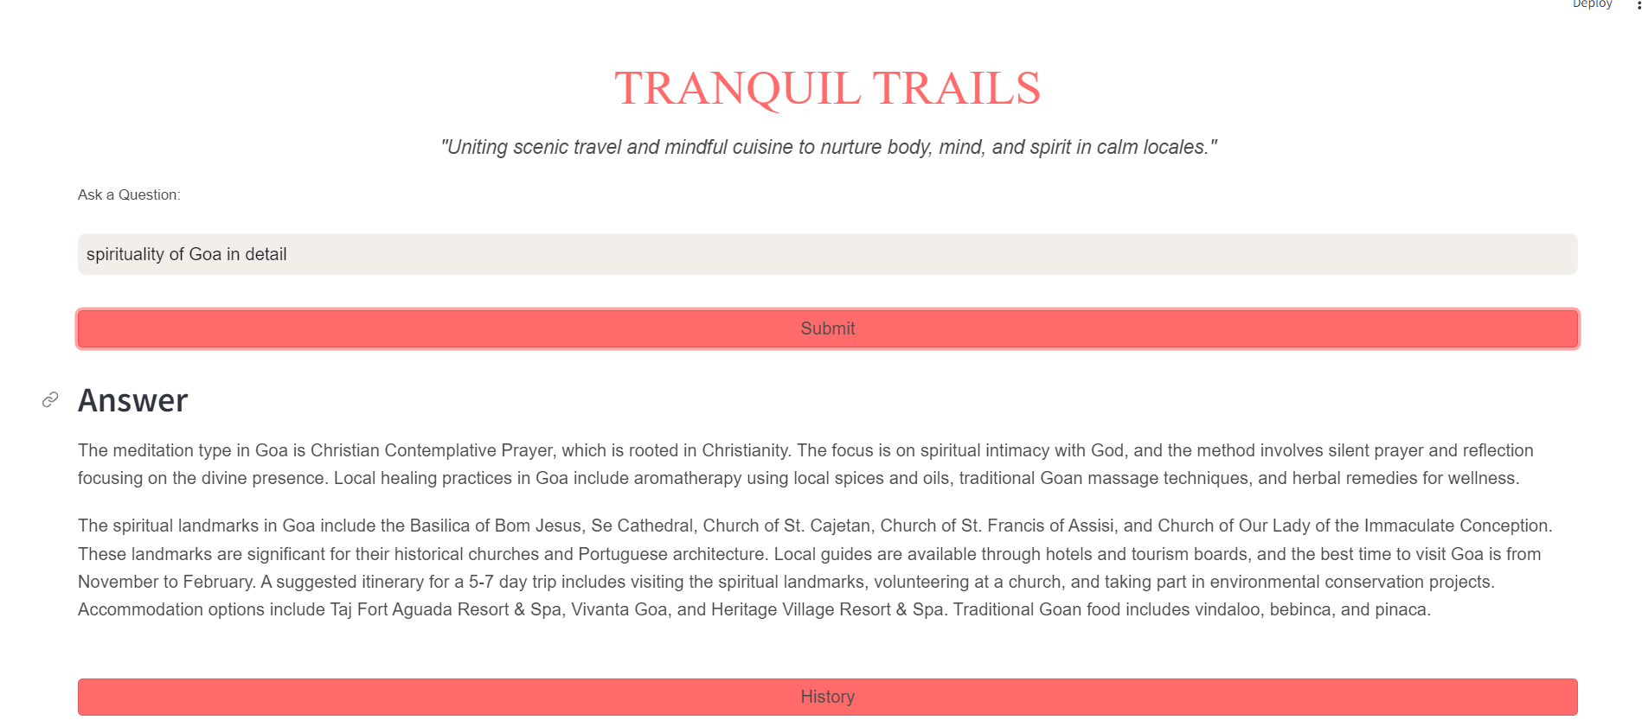Fig 4.1.1. : Output-1

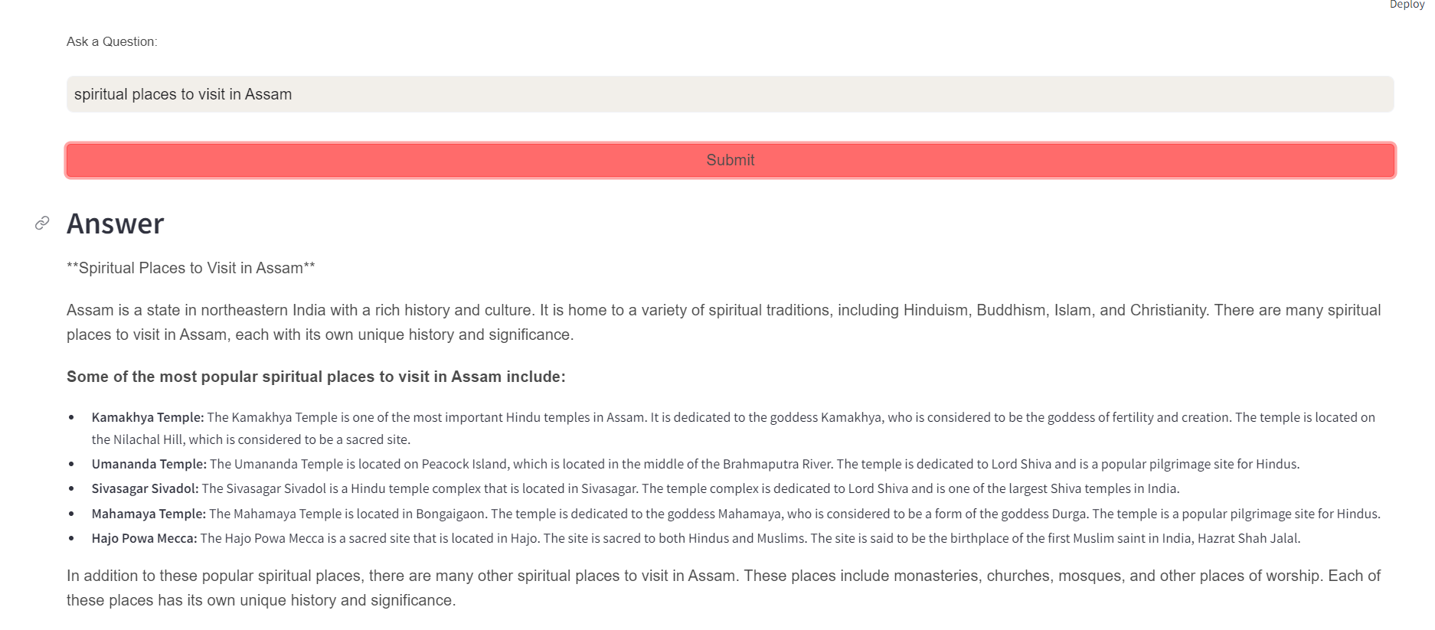

Fig 4.1.2. : Output-2

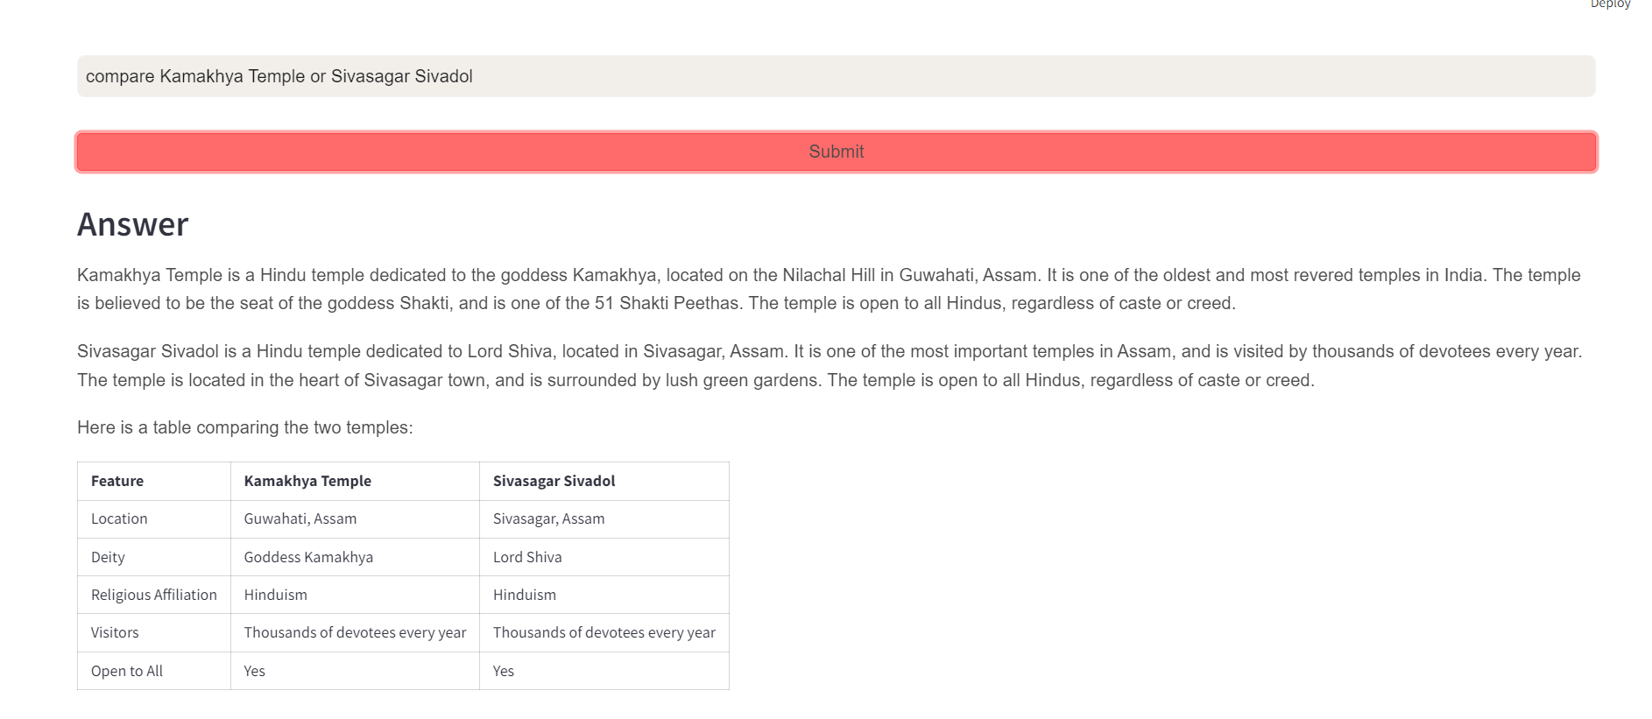

Fig 4.1.3. : Output-3

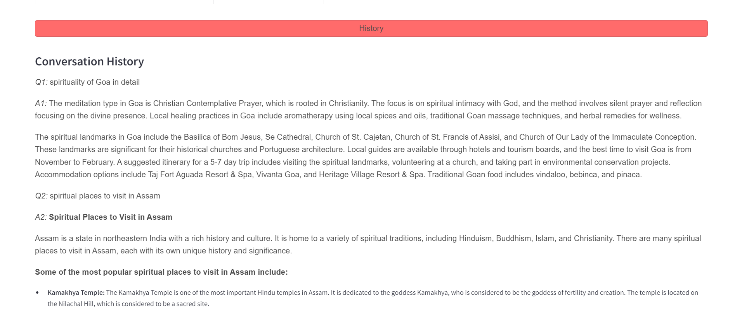

Fig 4.1.4. : Output-4

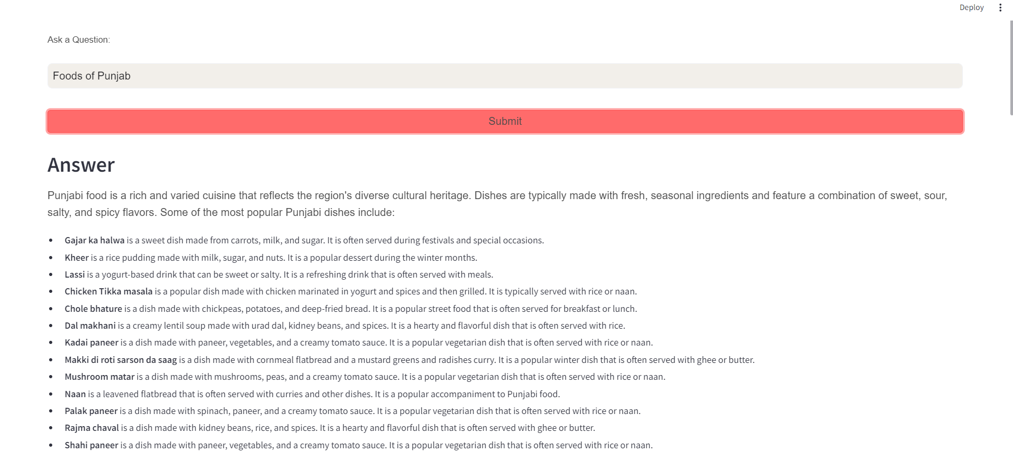

Fig 4.1.5. : Output-5

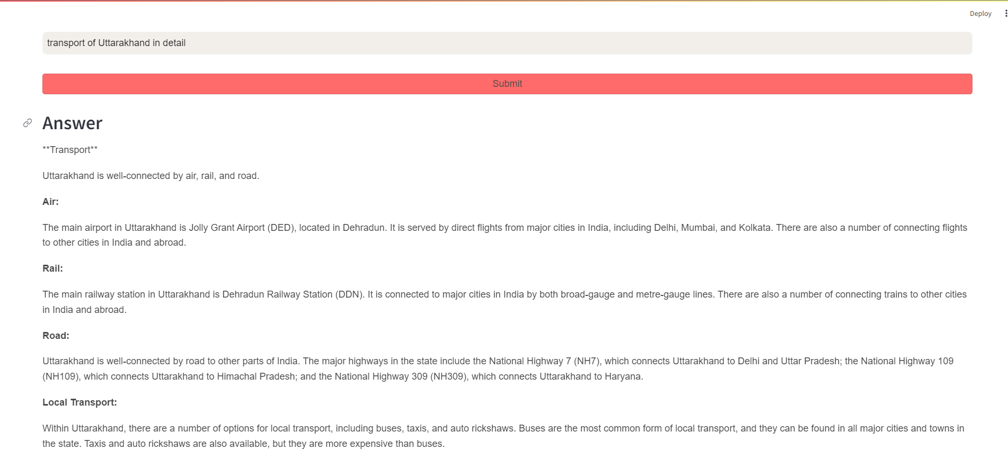

Fig 4.1.6. : Output-6

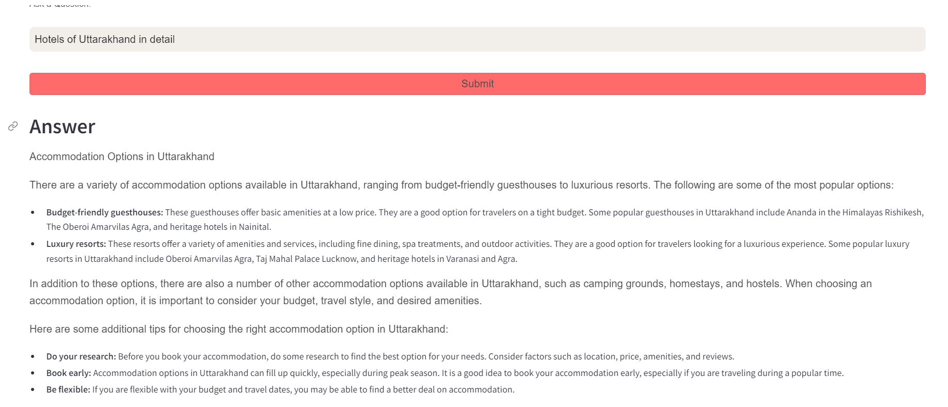

Fig 4.1.7. : Output-7

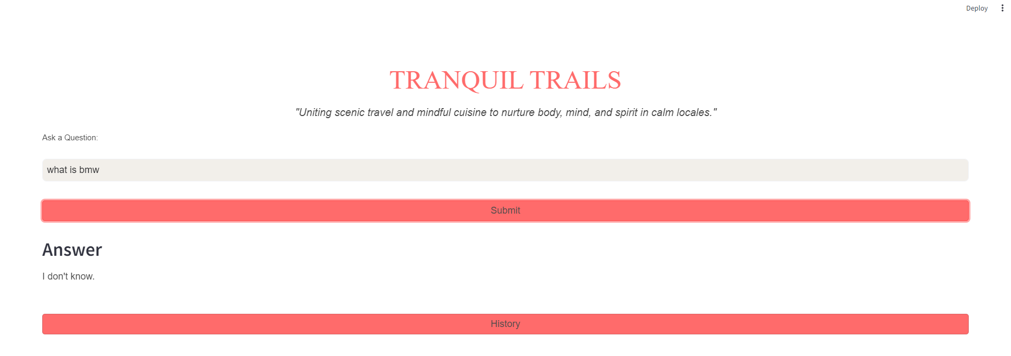

Fig 4.1.8. : Output-8

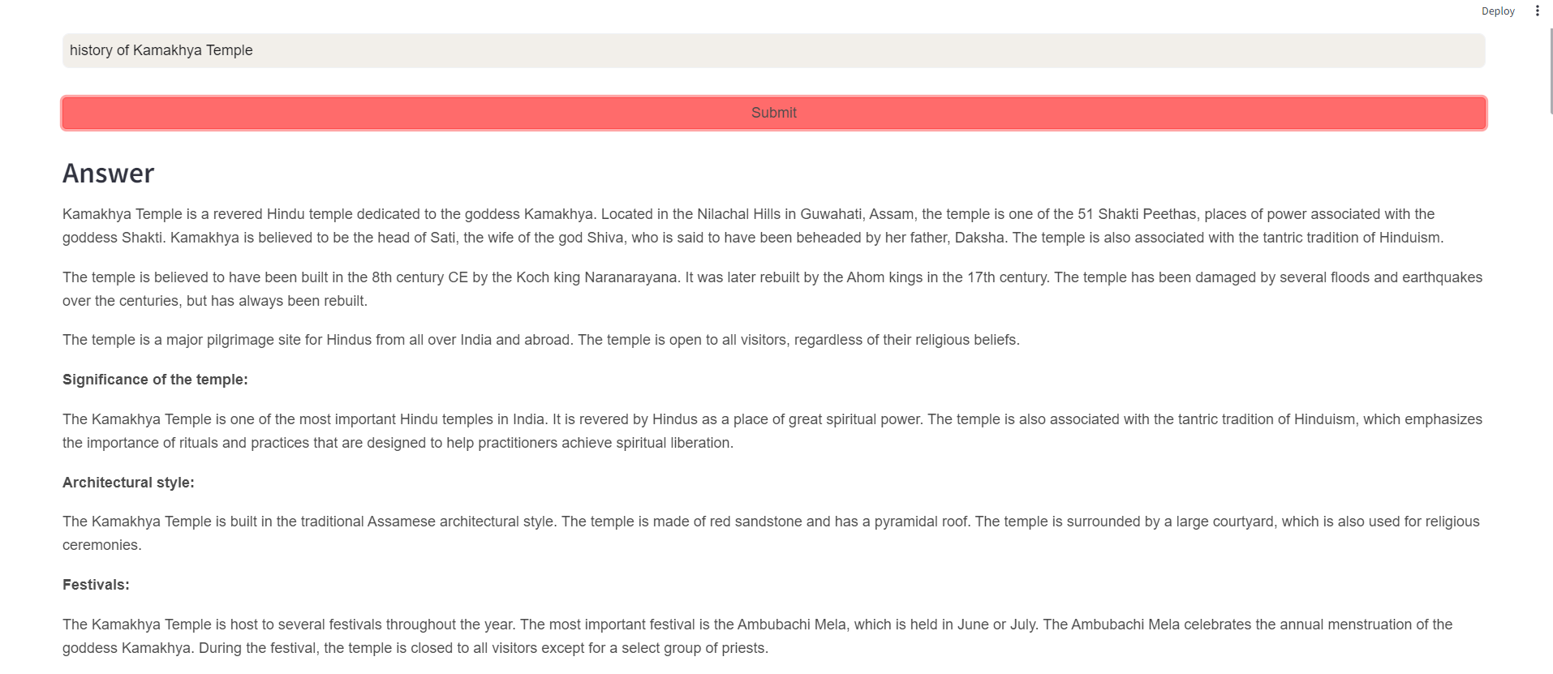

Fig 4.1.9. : Output-9

## 4.2 DISCUSSION

This project represents a significant advancement in the field of AI-driven information retrieval. Contextual understanding also plays a key role. By leveraging Google's Generative AI models and FAISS vector database the system processed and managed a complex dataset. This dataset contained detailed information on meditation practices. It also described spiritual landmarks. Local healing methods were outlined across various Indian states. Moreover, the embedding of this data using Google's Generative AI Embeddings methodology allowed for high-accuracy similarity searches. This ensured that relevant information could be retrieved quickly and effectively.

The creation of a custom prompt template was crucial for maintaining the contextual integrity of the responses. This template ensured that the answers generated by the QA chain were both accurate and comprehensive. It drew extensively from the source documents. These provided well-rounded insights. The seamless integration of the FAISS vector database with the GoogleGenerativeAI model facilitated the development. The system became a context-aware question-answering tool It serves as a valuable resource for users seeking detailed and reliable information on spiritual and meditative practices in India.

Overall the project showcases the potential of combining advanced AI models with robust data management techniques, and can lead to creation of intelligent systems. These systems are capable of understanding and they respond to complex queries with precision. Design and implementation are also a crucial part of this project, they demonstrate how careful planning can lead to highly effective information retrieval systems. This project offers a practical solution for users. It also contributes to the broader field of AI research. It illustrates the benefits of integrating different AI technologies to develop innovative projects.

# CHAPTER 5.

# CONCLUSION AND FUTURE ADVANCEMENTS

## 5.1 Future Advancements

Some future additions we can make in the existing model are as follows:

### **Enhanced Dataset**

Expand the dataset to include a broader range of global spiritual destinations, spanning diverse religions and practices. Enhance the dataset with detailed information on each location, including historical significance, local customs, key events, rituals, accommodation choices, nearby attractions, and optimal visiting seasons.

### **Inclusion of Images**

Incorporating high-quality images into our project is essential for enhancing its visual appeal and engagement. These images serve as powerful tools to captivate our audience's attention, making complex information more accessible and stimulating.

### **Language Support**

A language translation system for non-natives would help them communicate effectively with locals and understand local customs. It would offer real-time text and speech translation, along with cultural tips and etiquette advice to ensure smooth and respectful interactions. This system aims to bridge language barriers and enhance cultural understanding, making it easier for non-natives to integrate and navigate in a new environment thereby including inclusivity and increasing usability.

### **Community Building**

Develop community features where travellers can connect, share stories, and organise group trips. Additionally, allow users to share their spiritual travel logs, photos, and experiences, thereby fostering a vibrant sharing culture among members.

### **Collaboration**

Partnering with local guides and spiritual places can provide travellers with authentic and in-depth knowledge about the sites and practices they visit. Local guides, being well-versed in the history, culture, and traditions of their regions, can offer rich narratives and insights that go beyond what is typically available in guidebooks. Collaboration with spiritual places allows for a deeper understanding of religious practices, rituals, and philosophies, ensuring that visitors gain a respectful and comprehensive perspective on the local spiritual heritage.

### **Geo-Mapping**

It will include interactive maps with thorough descriptions and user evaluations will be featured, emphasising spiritual landmarks, meditation centres, and retreat places. In order to make sure that travellers have a smooth and fulfilling trip, it will also include sophisticated route planning capabilities, such as transportation options, projected travel times, and suggested itineraries.

### **Personalization**

Personalization can be incorporated to enable users to create personalised travel itineraries based on their interests, duration of stay, and spiritual goals. The platform can also be modified to recommend itineraries, activities, and landmarks tailored to user preferences and past behaviours.

## 5.2 Conclusion

This project illustrates how to combine vector storage databases and advanced AI models to create a successful context-aware question-answering system for spiritual tourism. This system's capacity to handle and integrate huge datasets makes it possible to efficiently retrieve and produce comprehensive, contextually relevant answers. The generated responses are guaranteed to be correct and based on the original documents when a well-defined prompt template is used. It also prevents the generation of unsupported information. This system showcases the potential of the Large language model for application in various domains where precise, context-specific information retrieval and QA capabilities are required.

# 

# REFERENCES

|  |  |
| --- | --- |
| [1] | J. Holdsworth, “What is NLP (natural language processing)?,” 6 June 2024. [Online]. Available: https://www.ibm.com/topics/natural-language-processing. |
| [2] | H. Naveed, A. U. Khan, S. Q. M. Saqib, S. Anwar, M. Usman, N. Akhtar, N. Barnes and A. Mian, “A Comprehensive Overview of Large Language Models.,” *arXiv preprint arXiv:2307.06435,* 12 July 2023. |
| [3] | K. D. Foote, “A Brief History of Large Language Models,” 28 December 2023. [Online]. Available: https://www.dataversity.net/a-brief-history-of-large-language-models/. |
| [4] | geeksforgeeks, “Introduction to LangChain,” 2024. [Online]. Available: https://www.geeksforgeeks.org/introduction-to-langchain/. |
| [5] | LangChain, “Langchain,” 2024. [Online]. Available: https://python.langchain.com/v0.1/docs/get_started/introduction. |
| [6] | LangChain, “Google Generative AI Embeddings,” 2024. [Online]. Available: https://python.langchain.com/v0.2/docs/integrations/text_embedding/google_generative_ai/. |
| [7] | Langchain, “LangChain Docs,” 2024. [Online]. Available: https://python.langchain.com/v0.2/docs/integrations/vectorstores/faiss/. |
| [8] | Streamlit, “Streamlit documentation,” 2024. [Online]. Available: https://docs.streamlit.io/. |